Itego

Testing RDM 2503
General Information
Content

1 Basics 3
1.1 Test User 3
1.2 Favorites 3
1.3 Test Cases 4
1.4 Test Landscape 6
1.5 Systems 7
2 Testplan and reporting issues 8
2.1 Test Plan 8
2.2 Reporting Issues 8
2.2.1 Get a number 8
2.2.2 Report the issue in Word 9
2.2.3 Link word to your test 11
2.2.4 Inform “Quality Management” 12

Basics

Test User

\\intern.itego.de\Public\Itego Reference Data Management\Testing\Tests RDM 2503

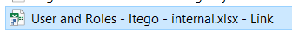

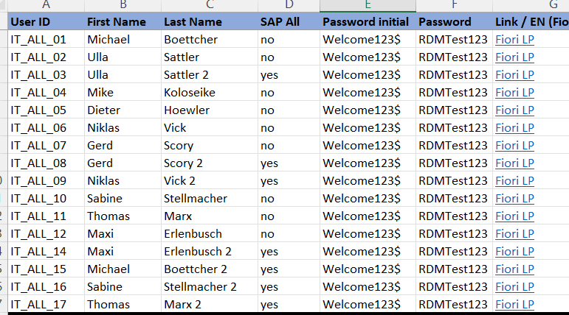
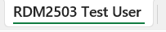

Always use the user without SAP_ALL. When you find an authorization issue, report it (adding SU53 *.html by save to file to the ticket) and use your SAP_ALL user.

Favorites

\\intern.itego.de\Public\Itego Reference Data Management\Testing

Users do not have favorites. Import them:

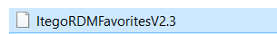

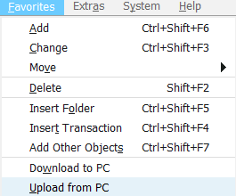

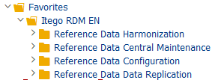

Test Cases

\\intern.itego.de\Public\Itego Reference Data Management\Testing\Test Cases

RDG
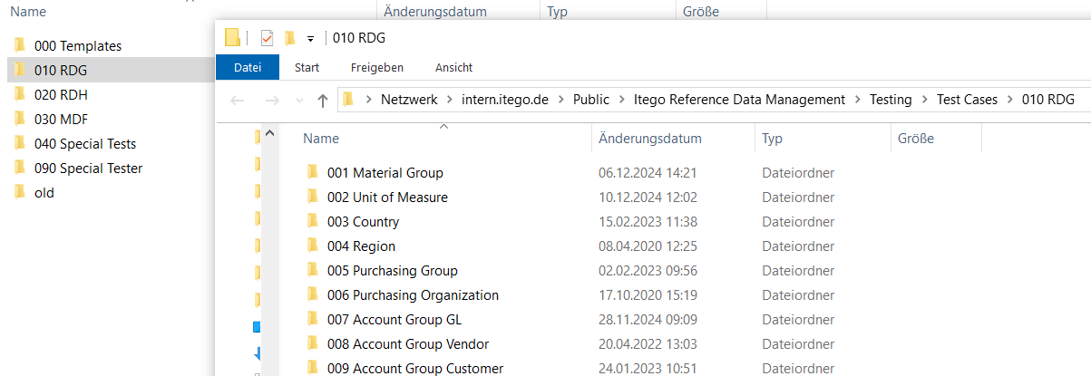

RDH
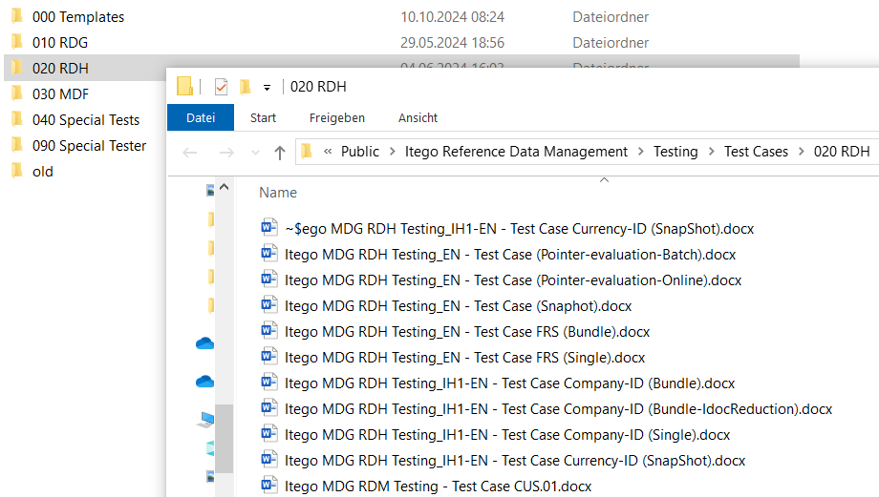

MDF

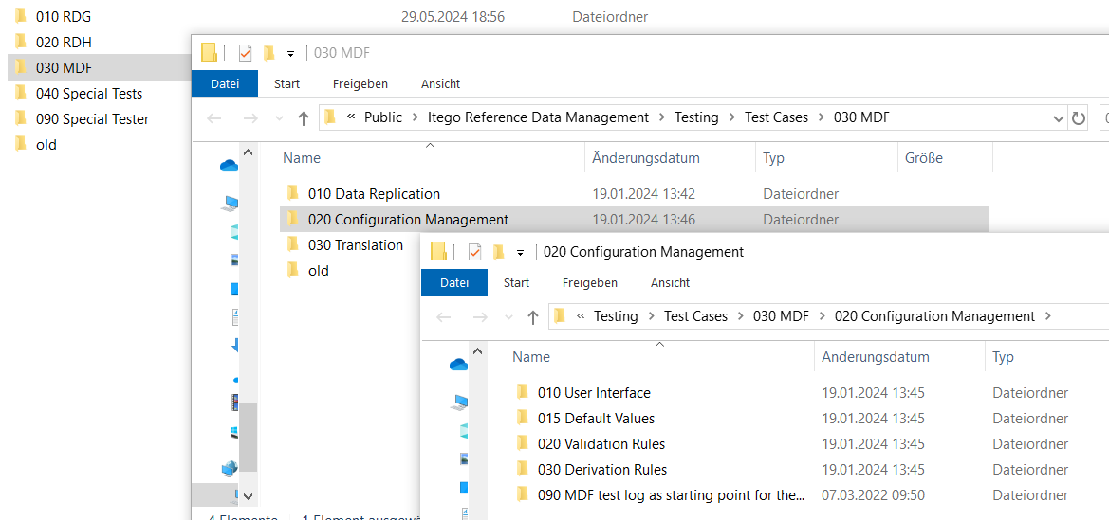

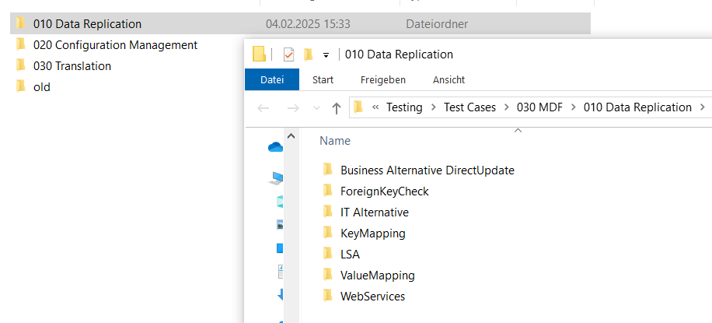

Test Landscape

\\intern.itego.de\Public\Itego Reference Data Management\Testing\Tests RDM 2503

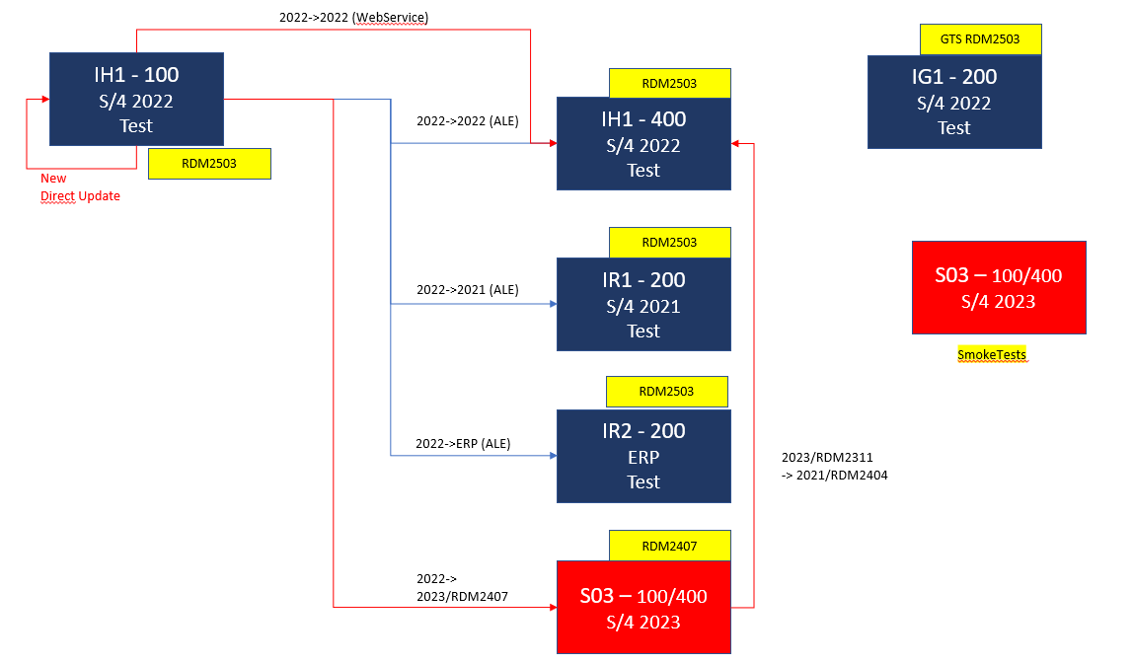

Systems

Depending on your test case start the system(s) if not already started.

Control Center
https://iww.itego.de/vm/

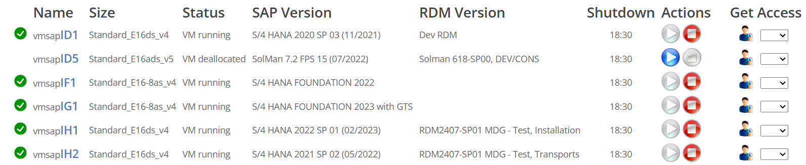

Start: 

Started 

Testplan and reporting issues

Test Plan

\\intern.itego.de\Public\Itego Reference Data Management\Testing\Tests RDM 2503

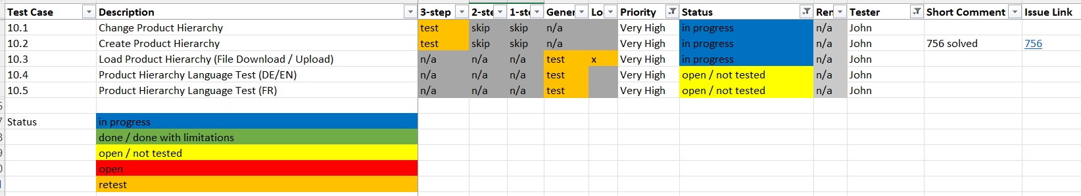

Select your name and work based on the priority (Very High first, ...). Choose only tests that are “open”. Do not choose “on hold”.

Please keep the status up to date. “Open / not tested” means: not started and might be given to somebody else if you do not change to “in progress”.

When you open this excel file please make sure that you close it again “as soon as possible” (others are using it as well).

Reporting Issues

\\intern.itego.de\Public\Itego Reference Data Management\Testing\Tests RDM 2503

Get a number

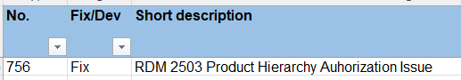

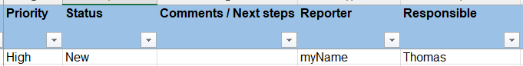

Reporter: you are the reporter => put in your name
Responsible: Thomas ... (Michael will also check)

Report the issue in Word

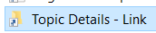

Copy:

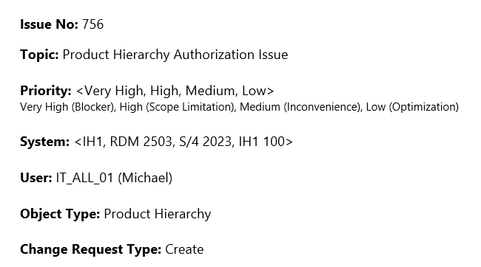

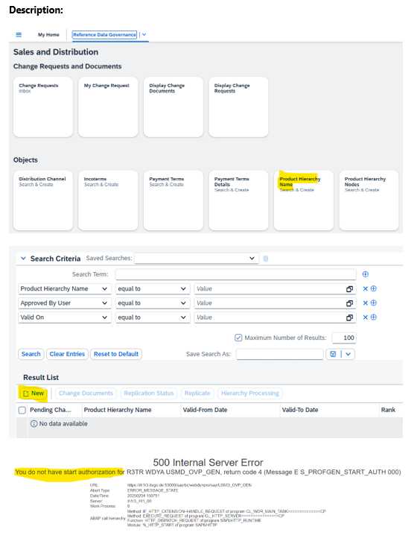

Note: Use “many” screenshots. This will make sure that the issue can be reproduced!

Link word to your test

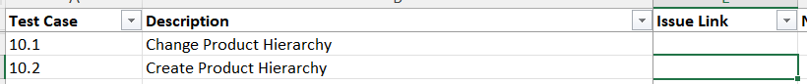

Right Click

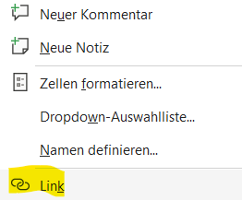

Link always starts with:
\\intern.itego.de\Public\Itego Reference Data Management\Topic Details\

and you need to add the name of your word document, e.g.
756 Itego RDM - 2503 Test - Product Hierarchy Authorization Issue.docx

So paste it like this:
\\intern.itego.de\Public\Itego Reference Data Management\Topic Details\756 Itego RDM - 2503 Test - Product Hierarchy Authorization Issue.docx

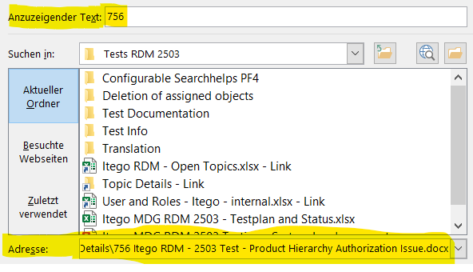

Text: just the number
Address: folder plus the name of your word file

You get this:
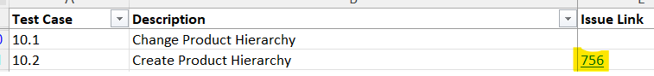

This will enable anyone to jump directly into your issue.

Inform “Quality Management”

Send an e-mail to Thomas thomas.marx@itego.de cc: michael.boettcher@itego.de with Subject: “756” Product Hierarchy Authorization Issue

And attach your document (pretty annoying if the receiver always needs to search for it).

